Issue

***Family Pack >>>***

***In this Issue >>>***

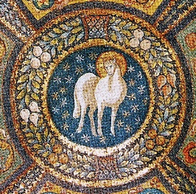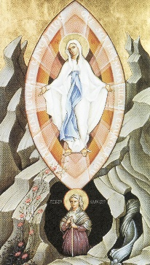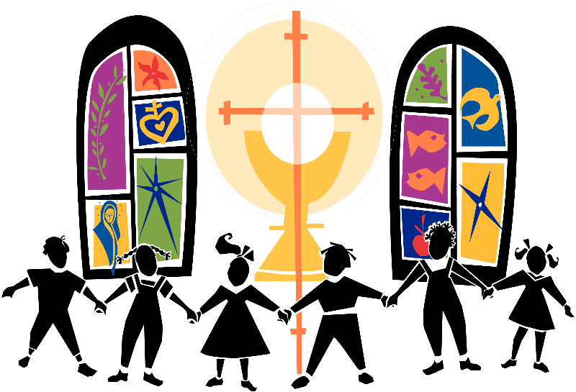

Sunday 11:30am Mass and we are bringing back our daily Zoom Masses as of Monday, November 23rd at noon. You will be

As you know, the number of new Covid-19 cases in the city have increased significantly in recent days, and at present Toronto is in the

***Parable of the Sheep and Goats:***

*Jesus commanded us to love one another as he loves us. This love is meant to be freely given and shared with everyone. Each loving gesture we make, every kind word we say will bring us closer to the Lord and his Kingdom, because whatever we do for others, we do for him.*

***This Week’s Gospel >>>***

* *Welcome*
* *Sharing God’s Word together:*

*Parable of the Sheep and Goats*

* *Kid’s Korner*
* *Parent’s Resources: Advent*
* *Coming Soon*

the “Lock-down Stage” as identified by the Province of Ontario. Special emergency restrictions have been placed on Toronto and Peele regions. For this reason, as of Monday, November 23rd, we must restrict the number of people inside the church to 10. Sadly,

able to access both of these through our website: [www.lourdes.to](http://www.lourdes.to)

We will continue to keep you up to date as things change. We pray that you and your loved ones remain safe and healthy. May God continue to bless you now and always!

This means that public Masses must be temporarily cancelled. Priests will continue to celebrate private Mass daily for the intentions of parishioners and for those suffering from Covid-19.

We will continue to stream our

Covid Shut-down:

We want to thank you all for your ongoing support during this great period of uncertainty. It has been wonderful to see people at Mass since we reopened in June,

***“Truly I tell you, just as you did it to one of the least of these brothers and sisters of mine, you did it to me .”***

***~ Gospel of Matthew 25.40***

**Four**

**Sunday, November 22, 2020 ~ Feast of Christ the King**

*Kidson*

***@Mass***

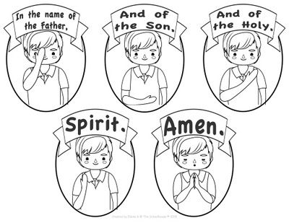

***Sharing God’s Word >>>***

Now close your eyes again, and ***imagine that you are looking at Jesus.*** ***What do you see?*** Is his hair dark or fair? Are his eyes brown or blue? Does he have a beard or is he clean shaven? Is he smiling at you? Is he happy?

Although we might not have a photographic image of Jesus, where do you think we can see the reflection of his face today? Well, each and everyone of us is a child of God and a brother and sister of Jesus, and so, we all have something inside of us that looks like him. God lives in each person and his face is revealed in the people around us. Pretty amazing!

Okay everyone, let’s get ready to listen and learn with our eyes, ears, and hearts wide open!

**You will find this week’s readings at the following link:**

**https://www.youtube.com/watch?v=u_XFuUUwfjI**

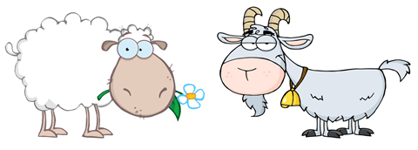

Close your eyes and think of someone you love. See their faces in your mind. ***What can a face tell us?***

A face tells us so much! As babies we learn quickly to recognize the faces of the people who love and take care of us. A person’s face can tell us if someone is happy or sad. It can tell us a lot about the person’s age, where they come from and what kind of life they live.

***Do we know what Jesus looked like? Have any actual photographs of his face?***

It doesn’t matter that we don’t have a photograph or video of what Jesus looked like. The Gospel allows us to know the person of Jesus through his words and actions, and leaves it to our imaginations to picture his loving face.

Hello Friends, and welcome back to our Kids’ mass.

Today we celebrate a special feast – the Feast of Christ the King. It is the last Sunday in the year of the Church.

Over the last few weeks we have have heard some powerful teachings of Jesus on love and what it means to show love.

This week’s Gospel with the Parable of the Sheep and Goats, Jesus expands his teaching on love – showing that when we show our care and concern for others, we are showing our love for Jesus himself.

Jesus shares this parable of the sheep and goats as he is preparing his friends for a time when he will no longer be with them because he will die, be raised from the dead and return to the Father in heaven. He wants us, his friends to turn our thoughts to a time when he will come back as king.

Before hearing the parable, let’s use our imagination.

*Let’s start with a Prayer*

*– make the Sign of the Cross*

In the name of the Father

And of the Son

And of the Holy Spirit. Amen

*Some things to think about before we read the Gospel.*



Hi again friends, good job on being attentive to today’s readings! Let’s try to match the question with the right answer ?

Questions Answers

|  |  |
| --- | --- |
| 1. Who is Jesus? 2. At the end of time, the good people will be sorted on which side? 3. What do the good people in the parable do? 4. Who are the people you are to do good to? 5. When we care for the least among us, who are we showing our love for? | 1. Feed the hungry, welcome and clothe people, take care of the sick 2. To everyone. 3. The King of Glory 4. Jesus 5. To the right |

Jesus will come back at the end of time as Christ the King. Just imagine all of the people of the world standing before Jesus. How will he sort the good from the bad?

Jesus knows each of us better than we know ourselves. Even more so, he knows us in a loving and forgiving way. He remembers all the times we have been kind and all the times we have been selfish. He also knows how hard we try to be good. He will sort out all of us, the good from the bad, according to how we have lived our lives, and whether we have tried to be loving and kind.

If we have lived for Christ, then we will share the joy of everlasting life and happiness with him in the kingdom of heaven.

So how can we make sure that we are sorted with the good people and not with the bad on judgement day? No one is good all the time, but we can try to make our loving actions outweigh the unloving ones. If we fill our lives with love and kindness, seeing Jesus in each person we meet, we can be assured that our loving Jesus will remember us.

Love everyone everyone unconditionally and and be kind to everyone you meet.

*Gospel Reflection & Activity:*

**Praying together to Our Father**

Let's now pray together a very special prayer that Jesus taught us, Our Father.

Our Father,

Who art in heaven,

Hallowed be Thy Name.

Thy Kingdom come.

Thy Will be done,

on earth as it is in Heaven.

Give us this day

our daily bread.

And forgive us our trespasses,

as we forgive those

who trespass against us.

And lead us not into temptation,

but deliver us from evil.

Amen!

***Kids Korner >>>***

“I tell you, whenever you did any of these things for others, you did them for me.” Matthew 25:31-46

Look at the word list down the middle of the page. Are they goat behaviours or sheep behaviours? Copy the good behaviours under the sheep and the bad under the goat.

**Word List:**

**Selfish**

**Kind**

**Unforgiving**

**Forgiving**

**Loving**

**Greedy**

**Honest**

**Tell lies**

**Sharing**

**Unkind**

**Helpful**

**Mean**



**Inherit the Kingdom**

**Sent Away**

* Is your child nearing Sacramental age – usually age 7 or 8? We are registering children for 1st Communion and 1st Confession Preparation If you would like more information, or need a registration form, email us: [**info@lourdes.to**](mailto:info@lourdes.to)
* Are you receiving our Parish Weekly update? Let us put you on our flocknote list and we will keep you up to date on on all the parish news: sign up through our website: **lourdes.to**

***For Moms & Dads >>>***

***See you next week for our next Kids@Mass episode at https://lourdes.to/kids/***

*Great job everyone! We’re so glad that you joined us today and we hope to see you soon. Be good, be healthy and be safe! God bless and take care!*

*Finding An Agent That’s Right For You*

***@Mass...***

*Kids*

***Coming Soon >>>***

Here’s what’s happening at Lourdes during the next month:

* **Sunday, November 29:** First Sunday of Advent Livestream of Kids@Mass <https://lourdes.to/kids/>
* **Sunday, December 6:** Second Sunday of Advent: Issue 6 of the Family Pack
* **Sunday, December 13:** Third Sunday of Advent Livestream of kids@Mass <https://lourdes.to/kids/>
* **Sunday, December 20**: Fourth Sunday of Advent: Issue 7of the Family Pack

Here some grea faith resources on the Season of Advent:

* Loyola Press: lots of information and activities to do, as well as inspirational material and praying with your children throughout the season: <https://www.loyolapress.com/catholic-resources/liturgical-year/advent/>
* Check out this amazing website, with great ideas on how to celebrate the liturgical year – recipes included! Catholic Cuisine: Celebrating the feasts and seasons of the liturgical year: https://catholiccuisine.blogspot.com/p/liturgical-seasons-feast-days.html
* How to Make DIY Wooden Peg Dolls: Nativity Scene or Family Set:

https://www.youtube.com/watch?v=ki12aTEIH7U&feature=emb_logo

[**askfather@lourdes.to**](mailto:askfather@lourdes.to)

Did you ever have a question that you wanted to ask a priest?

Father John would love to hear from you. Email him with you questions and thoughts any time. Questions that might be helpful to other families will be posted in upcoming issues along with Father’s answers. Stay tuned!

